**Assembly Closing Worship**

Sunday, June 1, 2025

**Prelude *I Have A Dream* (Mary Lou Williams)**

Mary Lou Williams (1910-1981) is one of the great jazz pianists, composers, and arrangers of jazz. Williams wrote and arranged for such bandleaders as Duke Ellington and Benny Goodman, and she was friend, mentor, and teacher to Thelonious Monk, Charlie Parker, Miles Davis, Tadd Dameron, Dizzy Gillespie, and many others. Through the 1960s she wrote extensive liturgical and sacred music including *Mary Lou’s Mass.* “I Have A Dream” was written as a response to Martin Luther King Jr.’s assassination and is based on the text of his famous “I Have A Dream” speech.

**Gathering Song *For the Music of Creation* (Nettleton)**

***For the music of creation, for the song your Spirit sings,***

***For your sounds divine expression, burst of joy in living things:***

***God, our God, the world’s composer, hear us, echoes of your voice;***

***Music is your art, your glory, let the human heart rejoice!***

***Psalms and symphonies exalt you, drum and trumpet, string and reed,***

***Simple melodies acclaim you, tunes that rise from deepest need,***

***Hymns of longing and belonging, carols from a cheerful throat,***

***Lilt of lullaby and lovesong catching heaven in a note.***

***All the voices of the ages in transcendent chorus meet,***

***Worship lifting up the senses, hands that praise, and dancing feet;***

***Over discord and division music speaks your joy and peace,***

***Harmony of earth and heaven, song of God that cannot cease!***

**Greeting**

The grace of our Lord Jesus Christ, the love of God, and the communion of the Holy Spirit be with you all. **And also with you.**

**Kyrie *The Spirit Is Moving: A Jazz Liturgy of Renewal***

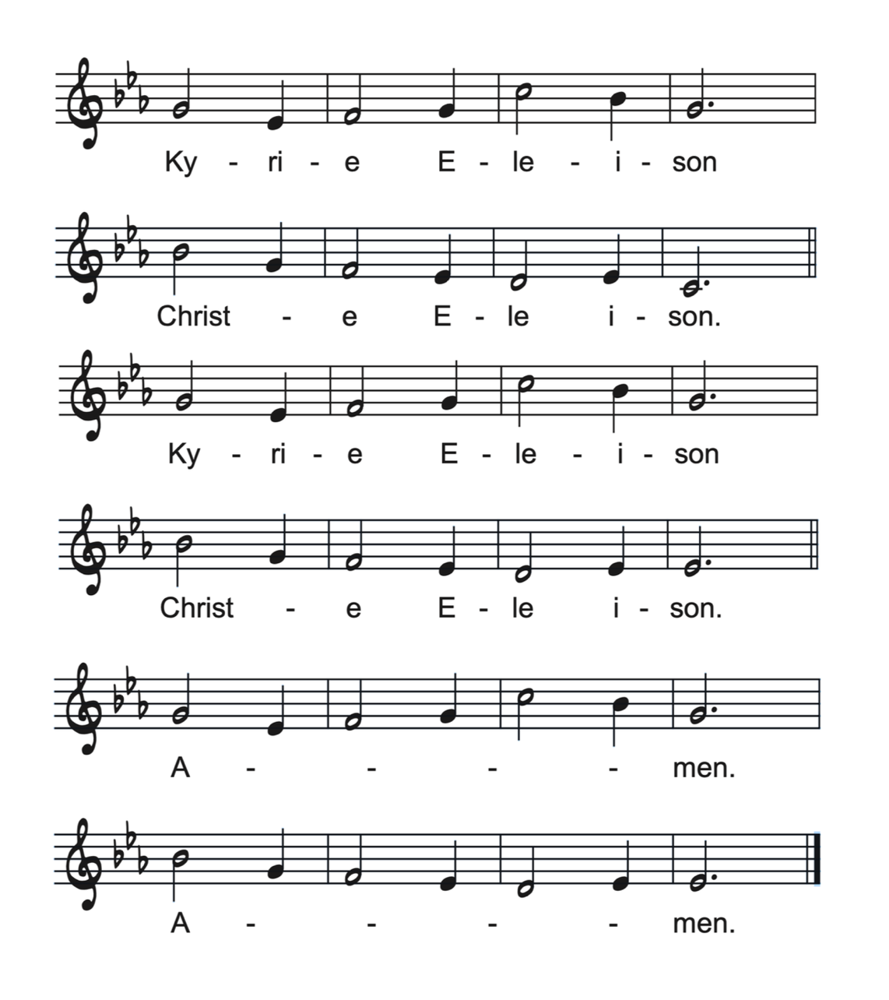

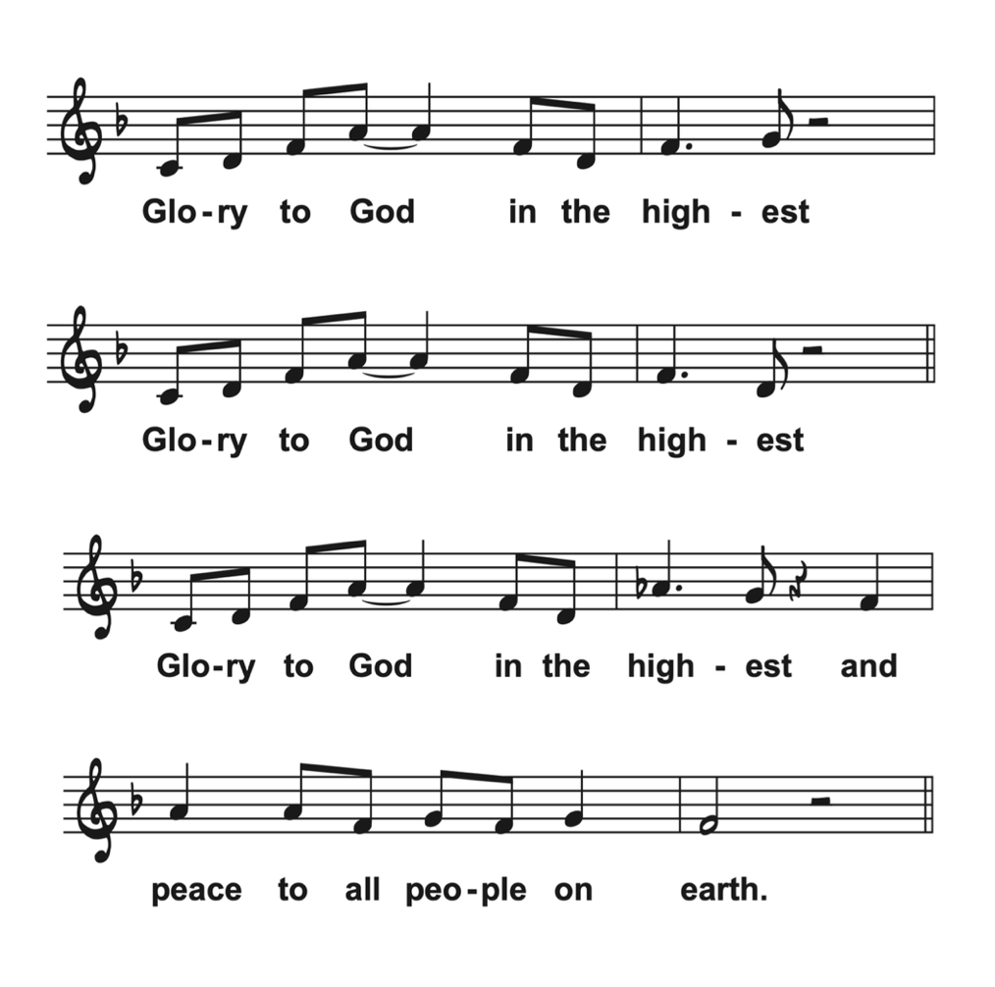**Glory to God**

Cantor:

*Glory to our God the Parent  
Glory to God the Son  
Glory to the Holy Spirit  
Glory to the three in one*

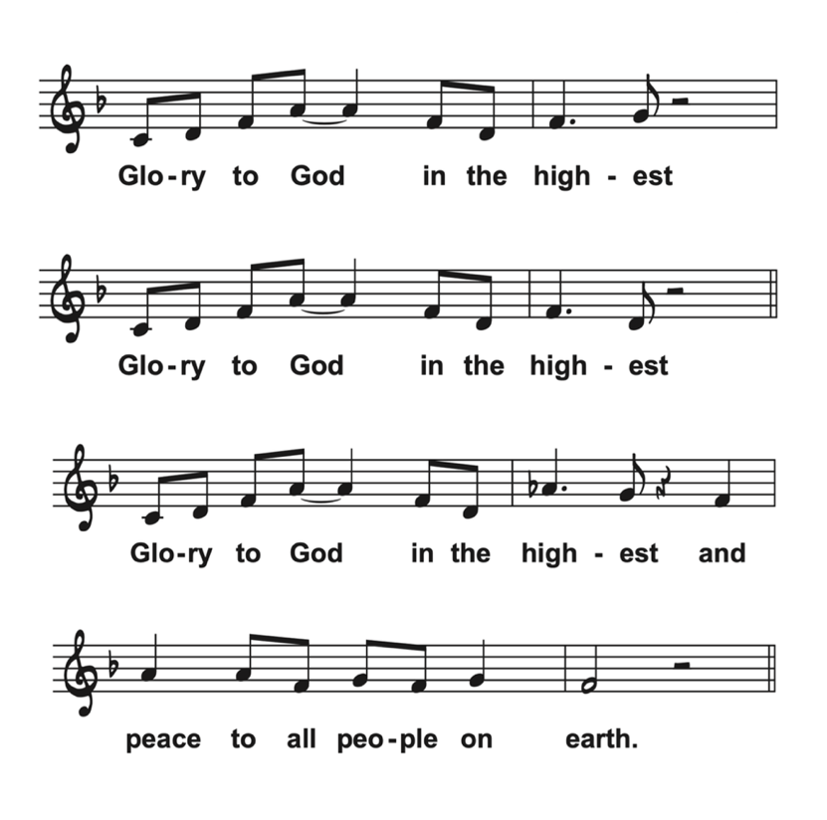**Instrumental Break**

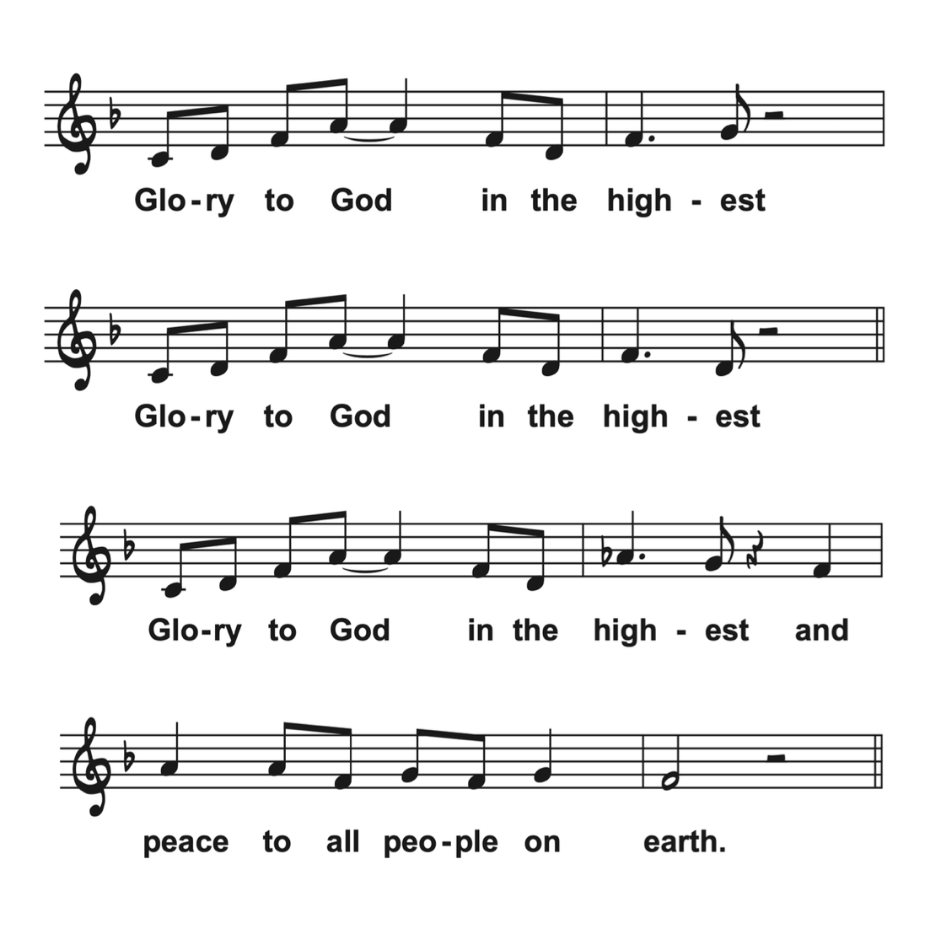

**Prayer of the Day**

Lifegiving God, we thank you, for you never stop creating or imagining. From the dawn of time to our mother’s womb, even in the age to come, your creativity is as endless as eternity. Divine Seamstress, today you are knitting your people into one garment of many colors. Weave us into your work, creating a world where the unity for which Jesus prayed is made real: a world where all are seen and welcomed as their authentic selves, included fully in the table of grace and mercy, and sent out to continue Jesus’ work to proclaim God’s unifying love to a hurting, divided world.

**Amen.**

**First Reading–Acts 16:16-34**16One day as we were going to the place of prayer, we met a female slave who had a spirit of divination and brought her owners a great deal of money by fortune-telling. 17While she followed Paul and us, she would cry out, “These men are slaves of the Most High God, who proclaim to you the way of salvation.” 18She kept doing this for many days. But Paul, very much annoyed, turned and said to the spirit, “I order you in the name of Jesus Christ to come out of her.” And it came out that very hour.19But when her owners saw that their hope of making money was gone, they seized Paul and Silas and dragged them into the marketplace before the authorities. 20When they had brought them before the magistrates, they said, “These men, these Jews, are disturbing our city 21and are advocating customs that are not lawful for us, being Romans, to adopt or observe.” 22The crowd joined in attacking them, and the magistrates had them stripped of their clothing and ordered them to be beaten with rods. 23After they had given them a severe flogging, they threw them into prison and ordered the jailer to keep them securely. 24Following these instructions, he put them in the innermost cell and fastened their feet in the stocks.

25About midnight Paul and Silas were praying and singing hymns to God, and the prisoners were listening to them. 26Suddenly there was an earthquake so violent that the foundations of the prison were shaken, and immediately all the doors were opened and everyone’s chains were unfastened. 27When the jailer woke up and saw the prison doors wide open, he drew his sword and was about to kill himself, since he supposed that the prisoners had escaped. 28But Paul shouted in a loud voice, “Do not harm yourself, for we are all here.” 29The jailer called for lights, and rushing in, he fell down trembling before Paul and Silas. 30Then he brought them outside and said, “Sirs, what must I do to be saved?” 31They answered, “Believe in the Lord Jesus, and you will be saved, you and your household.” 32They spoke the word of the Lord to him and to all who were in his house. 33At the same hour of the night he took them and washed their wounds; then he and his entire family were baptized without delay. 34He brought them up into the house and set food before them, and he and his entire household rejoiced that he had become a believer in God.

Word of God, Word of Life,

**Thanks be to God.**

**Psalm 97 Psalmody**

**Cantor:**

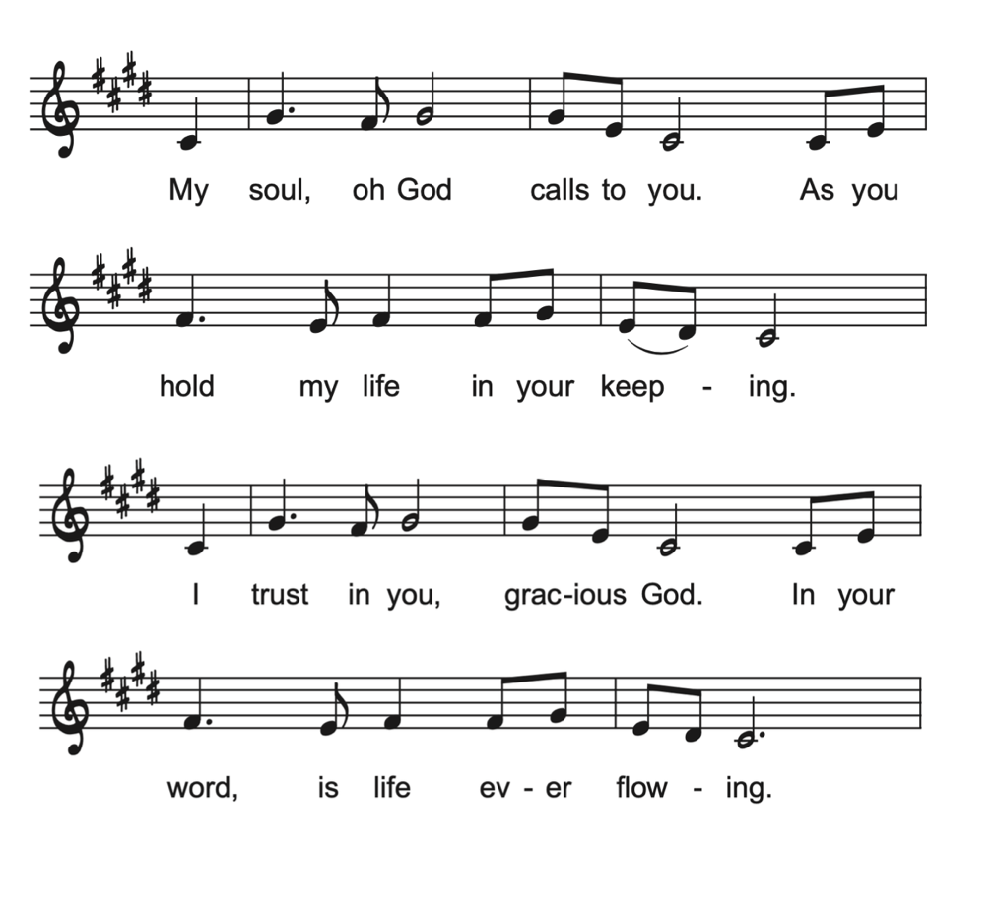

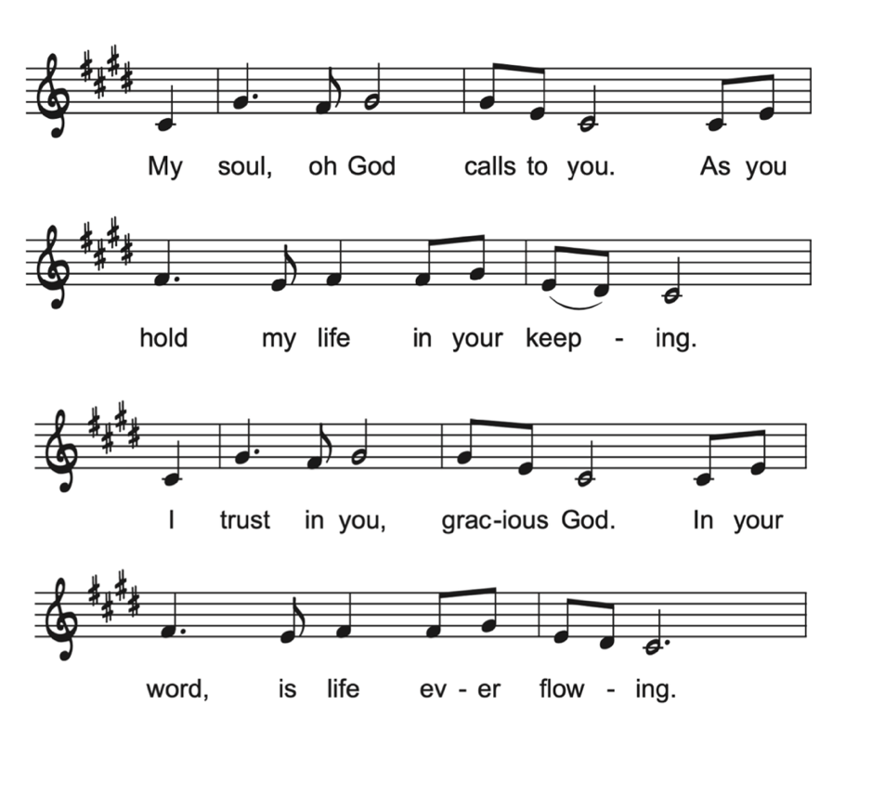**Congregation:**

The Lord reigns; let the | earth rejoice;

let the multitude of the | isles be glad.

**Clouds and darkness sur- | round the Lord,**

**righteousness and justice are the foundations | of God’s throne.**

Fire goes be- | fore the Lord,

burning up enemies on | every side.

**Lightnings light | up the world;**

**the earth | sees and trembles.**

The mountains | melt like wax

before the Lord of | all the earth.

**The heavens declare your righteous- | ness, O Lord,**

**and all the peoples | see your glory.**

Confounded be all who worship carved images and delight | in false gods!

Bow down before the Lord, | all you gods.

**Zion hears and is glad, and the cities of Ju- | dah rejoice,**

**because of your judg- | ments, O Lord.**

For you are the Lord, most high over | all the earth;

you are exalted far a- | bove all gods.

**You who love the | Lord, hate evil!**

**God guards the lives of the saints and rescues them from the hand | of the wicked.**

Light dawns | for the righteous,

and joy for the hon- | est of heart.

**Rejoice in the | Lord, you righteous,**

**and give thanks to God’s | holy name.**

**Congregation:**

**Second Reading–Revelation 22:12-14, 16-17, 20-21**12“See, I am coming soon; my reward is with me, to repay according to everyone’s work. 13I am the Alpha and the Omega, the First and the Last, the Beginning and the End.” 14Blessed are those who wash their robes, so that they will have the right to the tree of life and may enter the city by the gates.16“It is I, Jesus, who sent my angel to you with this testimony for the churches. I am the root and the descendant of David, the bright morning star.” 17The Spirit and the bride say, “Come.” And let everyone who hears say, “Come.” And let everyone who is thirsty come. Let anyone who wishes take the water of life as a gift.20The one who testifies to these things says, “Surely I am coming soon.” Amen. Come, Lord Jesus! 21The grace of the Lord Jesus be with all the saints. Amen.

Word of God, Word of Life,

**Thanks be to God.**

**Gospel Acclamation**

**Gospel–John 17:20-26**

Bishop Shoo (Swahili) Pastor President Pereyra (Spanish) Alison Richard (English)

20“I ask not only on behalf of these but also on behalf of those who believe in me through their word, 21that they may all be one. As you, Father, are in me and I am in you, may they also be in us, so that the world may believe that you have sent me. 22The glory that you have given me I have given them, so that they may be one, as we are one, 23I in them and you in me, that they may become completely one, so that the world may know that you have sent me and have loved them even as you have loved me. 24Father, I desire that those also, whom you have given me, may be with me where I am, to see my glory, which you have given me because you loved me before the foundation of the world.25“Righteous Father, the world does not know you, but I know you, and these know that you have sent me. 26I made your name known to them, and I will make it known, so that the love with which you have loved me may be in them and I in them.”

The gospel of the Lord.

**Praise to you, O Christ**

**Sermon *“One Church, Better Together”* Bishop Scott Alan Johnson**

**Song of the Day *Somos Uno en Cristo* ELW 643**

***Somos uno en Cristo, somos uno.  
Somos uno, uno solo.  
Somos uno en Cristo, somos uno.  
Somos uno, uno solo.  
Un solo Dios, un solo Señor,  
Una sola fe, un solo amor.  
Un solo bautismo, un solo Espíritu,  
Y ese es el consolador.  
  
We are all one in Christ, we are one body,  
All one people out of many.  
We are all one in Christ, we are one body,  
All one people out of many.  
There is one God, and only one Lord;  
There is one faith, one holy love.  
There is one baptism; there is one Spirit,  
Who is God the comforter.*   
  
*Somos uno en Cristo, somos uno.  
Somos uno, uno solo.  
Somos uno en Cristo, somos uno.  
Somos uno, uno solo.  
Un solo Dios, un solo Señor,  
Una sola fe, un solo amor.  
Un solo bautismo, un solo Espíritu,  
Y ese es el consolador.***

**Niceno-Constantinopolitan Creed**

*In 2024, the Lutheran World Federation and the Orthodox Church jointly affirmed a “Common Statement on the Filioque” – the addition of “and the Son” which has divided eastern and western churches for over 1,000 years. 2025 marks the 1700th anniversary of the Nicene Creed: in celebration of this anniversary and the reception of the Common Statement by our churches, we confess the Nicene Creed in its original wording at this year’s Nebraska Synod Assembly.*

**We believe in one God, the Father, the Almighty, maker of heaven and earth, of all that is, seen and unseen.**

**We believe in one Lord, Jesus Christ, the only Son of God, eternally begotten of the Father, God from God, Light from Light, true God from true God, begotten, not made, of one Being with the Father; through him all things were made. For us and for our salvation he came down from heaven, was incarnate of the Holy Spirit and the virgin Mary and became truly human. For our sake he was crucified under Pontius Pilate; he suffered death and was buried. On the third day he rose again in accordance with the scriptures; he ascended into heaven and is seated at the right hand of the Father. He will come again in glory to judge the living and the dead, and his kingdom will have no end.**

**We believe in the Holy Spirit, the Lord, the giver of life, who proceeds from the Father, who with the Father and the Son is worshiped and glorified, who has spoken through the prophets. We believe in one holy catholic and apostolic church. We acknowledge one baptism for the forgiveness of sins. We look for the resurrection of the dead, and the life of the world to come. Amen.**

**Prayers of Intercession *Yarraba Ssalami***

Trusting in the One who made us, dwells in us, and calls us to life, we pray for the world, the church, and all in need.

Welcoming God, you invite all people to come and encounter your love. Teach us to love neighbors who live in different skin. To love intelligences and abilities of all kinds, and loving-kindness most of all. Make us bold in our proclamation that the lives, loves,  and gifts of LGBTQIA, BIPOC, Incarcerated, Disabled, and Migrant people matter to you, and so they matter to all of us –manifest in both word and deed. God of grace,

***Yarabba ssalami***

***amter alayna ssalam,***

***yarabba ssalami,***

***im la' biladina ssalam.***

Creating God, who paints the skies in every hue, we praise you for morning and night, for dawn and dusk, and for every moment in between. We praise you for the vibrant, loud, and serene colors of creation. We revel in the ever-changing of the seasons. We thank you for the infinite and as-yet undiscovered diversity of your creatures, of galaxies beyond our imagining. Teach us to feel awe again. Teach us to see and celebrate the stunning beauty in all you have made. God of grace,

***Let your peace rain upon us,living God of peace.***

***Let your peace rain upon us,***

***Lord, fill our country with your peace.***

Discerning God, fill the hearts of leaders with your passion and justice for mercy.  Call the nations of this world to tables of peace and collaboration. Help us to end violence and restore communities. Encourage governments to seek avenues of collective benefit and joy. God of grace,

***Yarabba ssalami***

***amter alayna ssalam,***

***yarabba ssalami,***

***im la' biladina ssalam.***  
  
Abiding God, all people are held in your care.  Accompany survivors of abuse, trauma and exploitation. Strengthen our resolve to listen and advocate on behalf of all who are unnoticed, especially the hungry, those without homes, the refugee, and the stranger. Help all to know they are beloved by God, and worthy of love.  God of grace,

***Let your peace rain upon us,living God of peace.***

***Let your peace rain upon us,***

***Lord, fill our country with your peace.***Loving God, the beginning and the end, you are with us throughout our lives. In gratitude for the saints who have died, we look toward your coming again among us. WE REMEMBER ESPECIALLY, Rev. Dr. Mary Jensen, PMA Rodney Hansen, Rev. Kent Morse, Rev. Alton Schwandt, Rev. Baron Cole, Rev. Dr. Olaf Roynesdal, Rev. Glenda Ferguson. God of grace,

***Yarabba ssalami***

***amter alayna ssalam,***

***yarabba ssalami,***

***im la' biladina ssalam.***

We commend these and all our prayers to you, O God, trusting that you are always with us; in the name of Jesus Christ, our risen Savior. **Amen.**

*Prayers adapted from the following sources:* Sundays and Seasons *and Reconciling Works’* Deepening and Expanding Worship

**Sharing the Peace**

Salaam! Fred! Pokoj! Rauha! The peace of Christ is with you always.

**And also with you.**

**Offering** *Offerings given will be shared with our companion synods who are with us this weekend.*

**Musical Offering *Come Sunday* (Duke Ellington)**

“Come Sunday” was written by Duke Ellington in 1942 and premiered at Carnegie Hall on January 23, 1943 as part of a larger work entitled “Black, Brown and Beige”. Ellington introduced the suite as "a parallel to the history of the Negro in America." “Come Sunday” was included in a popular 1958 recording with Mahalia Jackson and again as part of Duke’s *Concert of Sacred Music* in 1965.

**Offertory Prayer**

Let us pray*.*

Gracious God, you bless us with gifts of guidance, new life, growth in grace, and fruitful labor. Accept the first fruits of time and toil, field and orchard, which we offer here. Bless and multiply these gifts to our nurture and the care of your creation, for the sake of your Son, our Savior Jesus Christ.

**Amen**

**Thanksgiving for the Word**

Holy God, our Maker, our Healer, our Teacher, your magnificent creation springs forth from your Word. All that has life and breath praises your name.

For your Word that sustains the earth, we thank you, O God.

**We thank you, O God.**

You sent us Jesus, your Word, to renew the world. He healed the sick, fed the hungry, preached your mercy, and called us to faith.

For your Word in our Lord Christ, we praise you, O God.

**We praise you, O God.**Nourish us with the Spirit of your Word, that we may grow in grace, bearing the fruits of redemption, and sharing your strength and beauty with all the world.

For your Word in our lives, we entreat you, O God.

**We entreat you, O God.**Accept our thanksgiving and receive our prayer, for the sake of your living Word, Jesus our Savior.

**Amen.**

**Blessing and Sending**

As we are sent from this holy space and holy time, let us affirm our call to Christian vocation.

Beloved of God, both your work and your rest are in God. Will you endeavor to pattern your life on the Lord Jesus Christ, in gratitude to God and in service to others, at morning and evening, at work and at play, all the days of your life?

**I will, and I ask God to help me.**

Let us pray.

Almighty God, by the power of the Spirit you have knit these your servants into the one body of your Son, Jesus Christ. Look with favor upon them in their commitment to serve in Christ’s name. Give them courage, patience, and vision; and strengthen us all in our Christian vocation of witness to the world and of service to others.

Renew in us the commitment to use our gifts in the service of others, and especially of those in need. Let us be your hands to feed the hungry, shelter the homeless, clothe the naked, comfort the weary and outcast, welcome the stranger, care for creation, and be loving neighbors to all people.

Bless us as we go out from here to live and labor in our home congregations and communities. Prosper the work of our hands. May the gifts we use and share be signs of your love to all people, through Jesus Christ our Lord. **Amen.**

**Sending Song *We Are Marching in the Light of God* ELW 866**



**Dismissal**

Go in peace to love and serve God, to live out your Christian vocation, and to imagine…

**Thanks be to God!**

*The Spirit is Moving: A Jazz Liturgy of Renewal* and hymn arrangements by Jon Ailabouni. Used with permission. Published by Jon Ailabouni Music (ASCAP).

All music and liturgical texts reproduced in this service (unless otherwise noted) are used by permission under the following licenses:

OneLicense: A-723746

Augsburg Fortress Liturgies Annual License: SAS027327

Sundays and Seasons Hymns and Songs License: A723746

CCLI: 1891425

From sundaysandseasons.com. Copyright © 2025 Augsburg Fortress. All rights reserved.

**Thank you to our musicians!**

**Jon Ailabouni – trumpet**

**Mindi Hadan – vocals**

**Sean Lebita – piano**

**Jonah Bennet – bass**

**Kendal Wooden – drums**

For more information about Jon Aliabouni and The Spirit is Moving: A Jazz Liturgy of Renewal

