“Go therefore and make disciples of all nations, baptizing them in the name of the Father and of the Son and of the Holy Spirit, and teaching them to obey everything that I have commanded you. And remember, I am with you always, to the end of the age.” (Matthew 28, 19-20, NRSV)

Tips for a potential Fall 2023 Financial and Holistic Stewardship Campaign emphasis for your congregation, and the congregations of the Nebraska Synod.

Overview of this Resource
This resource is meant to help get the creative ideas flowing for your congregation. Though it is being created for Fall 2023, it could easily be adapted for other times of the calendar year, or even extended into a year-long emphasis, especially when paired with the “Go And…Stewardship Preaching Ideas” resource. These tips may be useful to help construct a meaningful stewardship campaign in your congregation, but they are not exhaustive, and this is not a “plug and play” resource. This is intentional, because the most effective resources like this are adapted to best fit and reflect the unique congregational context in which they will be utilized.

For most effective congregational use, an appointed team needs to take the lead to oversee the planning, implementation, execution, and follow-up for this sort of a stewardship campaign. This could be the work of a: stewardship team, the mission team, the finance team, a special group designated by Church Council, etc.

The three-month approach that follows connects with the Nebraska Synod’s 2023 “Go And…” series focus, and to some degree is adapted too, to incorporate the three elements of financial stewardship that Rev. Chick Lane writes about in his book Ask, Thank, Tell, though the order is slightly adjusted here. In this series, September is imagined to be more about “telling” what your congregation does or may be called to do. October is more about asking for ideas, input, and contributions to both be a part of the ministry and work with one’s time, strengths, and passions, but also through their monetary and financial means as well. November then, is largely about saying thank you.

The three-month focus then as outlined in this resource is as follows:
- September 2023- Go and… Serve with Your Neighbor: Share about God’s work that is happening and is made possible through you and your congregation.
- October 2023- Go and… Ask: Invite and ask others to join in through all that God has entrusted them with- their gifts, strengths, time, talents, assets, etc.
- November 2023- Go and… Be Honest: And Give Thanks!

To make this happen most effectively in your congregational context, it is recommended that the planning occur at least a couple months prior to execution, and that as part of the plan, there is a strategy for follow-up and next steps following the three-month period.

September 2023- Go and… Serve with Your Neighbor
Monthly Overview and Description: The month’s themes in worship include emphasis on our relationships with neighbors, vocation, and being in community with one another. These themes are prime invitations for congregations to share examples in story form, sermons, videos, and other short reflections about how the congregation meets its neighbors where they are at, what kind of ministry it does, and the impact(s) of that ministry.

How might you invite a few key individuals who have seen God’s life changing and life-saving love in real-time share a story or observation with the larger congregation? Perhaps a short story during the offering time in worship? A Temple Talk? A sermon illustration? An adult forum or Sunday School teaching opportunity? The possibilities are many. But in a three-month focus such as this, this is about setting the stage to say:
“We as ___________(name of congregation)____, “Go and…” by __________________. Here are some of the stories of God’s love and work made real through you and in part because of your generosity and stewardship.”

Telling the story about how your congregation serves, and God’s work and mission that it is a part of, is always critical, but especially when thinking about stewardship. To this end, an intentional strategy of sharing personal and congregational stories would go a long way as part of this campaign. Though the pastoral leader certainly can tie in these themes (and should) in preaching; messages and stories like these go a longer way generally when shared by one’s peers in the pews. This could be an important role of a congregation’s stewardship team to invite stories to be shared and help plan how they will be shared and used, along with the pastoral leader/staff of the congregation.

Recommended Resource for September: Narrative Budget
To help illustrate all the ministry and service that the congregation makes possible, you may discern that having a form of a Narrative Budget would be helpful. If this is new to your congregation, or if you have not had one in a while, the Narrative Budget resource available on the synod stewardship website could be a great tool to engage. The Narrative Budget resource walks you through step by step how to go about creating one and sharing the story that it tells with the larger congregation and community. You can find the resource here: https://nebraskasynod.org/wp-content/uploads/2021/07/Narrative-Budgets.pdf. An example pie chart that might be part of a narrative budget can be seen below to visually represent the proportions of how a church budget is allocated towards various ministries:

October 2023- Go and… Ask
Monthly Overview and Description: The emphasis on story telling continues into the second month of the campaign. This month’s themes in worship include some good questions, rejoicing and praise, and the importance of stepping up with what God entrusts for the sake of the world and our neighbors.

This would be the ideal time to distribute a sort of “Commitment” or pledge card. Particularly, the readings on Sunday, October 15th are ideal for this, as the appointed epistle lesson that day comes from Philippians 4:1-9 with the famous verse, “Rejoice in the Lord always; again I will say, Rejoice.” If your congregation were to create these, some intention needs to be given to who will receive them, what information you are seeking, and what might they look like? But also, what will the church do (if anything) once they are returned? Will these commitment cards be between an individual household and God, and sealed and stored by the altar and then returned sometime in the year ahead to those who filled them out to reflect, remember, and see how they are doing related to their plan or commitment? Or will they be viewed, seen, and logged into a sort of spreadsheet by a few trusted individuals? Neither (or any approach) is wrong, but it is essential that the plan be clear and transparently shared with the congregation ahead of time.

As we “Go and Ask…” how might you ask the disciples and stewards in the congregation to discern and potentially step up and/or into something? Again, this sort of process always is most effective when led and shared by one’s peers and not necessarily the pastoral leader up front. If cast under a wide vision of how your congregation is called to “Go And,” it could have a large positive impact.

Better yet, if your congregation’s council or a particular team has discerned strengths, passions, and gifts in those in your faith community, perhaps this might be a time to intentionally invite people into the opportunity to serve in new and exciting ways because one has seen or sensed unique particular gifts that they have and might be willing to share them as part of God’s work.

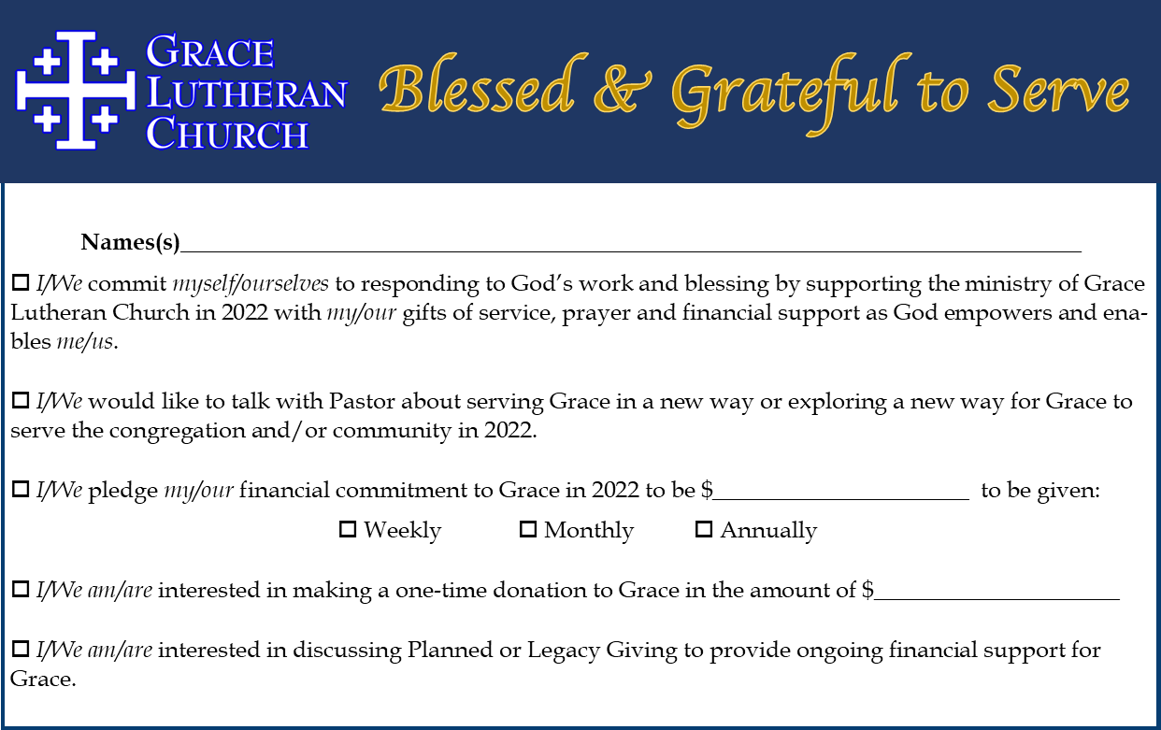
A popular method towards this end has been some sort of “Time and Talents” sheet or survey, or even a “Gifts sheet.” If your congregation were to use something like this, spend plenty of time before distributing them, to know what the plan will be for using the information and responding to those who fill out the forms after the fact. That way the input shared can be connected with the appropriate teams, ministries, or people regarding whatever one might have a question about or potential interest in. If your congregation goes this route, consider using “Commitment” or “Consecration” Sunday as an opportunity to both receive financial commitments and time and talent responses, reflecting the more holistic nature of stewardship.

Suggested Resources for October: Commitment Card and/or Time and Talents
A simple Google Search will lead to all sorts of possible templates and advice for creating commitment or pledge cards, and/or Time and Talents surveys. Grace Lutheran Church in Yorktown Heights, NY shares their simple but effective commitment card as one example which can be found here to fill in online or download: https://graceyorktown.org/2022-commitment-form/.
The ELCA has a resource that walks you through discerning and implementing such a commitment card. You can find that resource here: https://download.elca.org/ELCA%20Resource%20Repository/Make_It_Simple_How_to_Use.pdf. With related materials available here: https://download.elca.org/ELCA%20Resource%20Repository/Make_It_Simple_Commitment_Cards_and_Giving_Cha.pdf.

If considering using a Time and Talent Survey, consider both a digital online form format, and a hardcopy version for those who would rather fill out a survey by hand. A good example of what an online form might look like can be found from Abiding Savior Lutheran in Church in Mounds View, MN, as found here: http://abidingsavior.org/OutreachPro/time-and-talent-survey/. Another somewhat more visually appealing example comes from a Missouri Synod congregation, Holy Cross Lutheran Church and School in Wichita, KA, which can be found here: https://holycrosslutheran.net/time-and-talents/.

Some congregations have adapted the idea of a Time and Talent Survey into what is called a “Gift Sheet.” This move is an intentional nuance to focus more on individual gifts and talents, as opposed to jobs that just need to be done. This move helps the congregation to lean into a sense of call versus just filling needed spots or roles. Some roles or ideas for this might include asking about gifts of people as “organizer, behind the scenes worker, creative thinker, etc.” These are titles that don’t necessarily correspond to a job that needs to be done but recognize unique gifts of the individual as a gifted and beloved Child of God.

My most important piece of advice about Time and Talents surveys and gifts sheets, is a caution and affirmation. These can be great tools. But they are only as great as the plan and implementation for how the information gathered will be used and followed-up with. If there is no plan, then it is not recommended that a congregation create such a survey (of any kind). But if there is a plan for how to use the information received, and to connect the information received with those who will help empower and equip ways for people’s gifts, strengths, ideas, passions, etc. to be utilized, then this tool can become a real gift for congregational vitality. This can also be useful to surface gifts and interests that are unknown in the congregation, or that some just aren’t aware of that are present within the faith community. An effective slide or advertisement for this can be seen below from Peace Lutheran in Sioux Falls, SD.

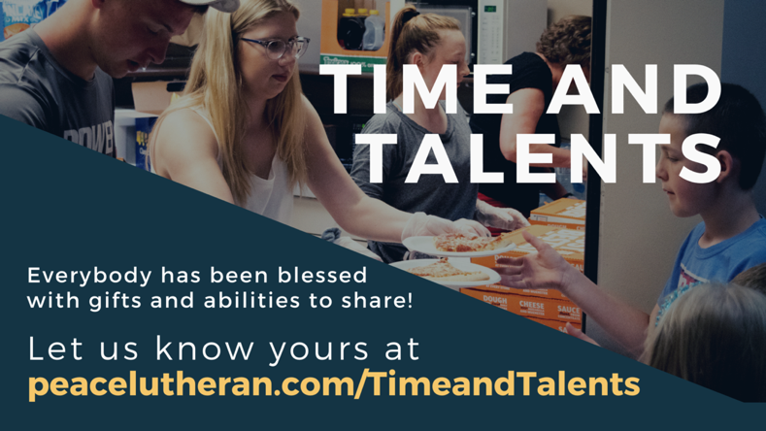

Note: Putting the Pieces Together
If utilizing a Narrative Budget, consider how your congregation can return to this resource throughout the three months of this campaign. For example, after the “Asking” stage is over, how might you communicate, “Because of your gifts we can….” In thinking about the visuals of a Narrative Budget, and the potential use of a pie chart like shown on page 2 of this resource, what might it mean to show a portion of the budget as “uncommitted dollars” that are set aside for the unknown opportunities God is bound to provide? Such a move would be a move of trust and faith, but also one of abundance. That uncommitted portion could even be set at 10%, as an effective tithe of the congregation’s budget to be allocated towards whatever needs or new ideas God might be bringing forth to the congregation’s attention and imagination.

November 2023- Go and… Be Honest (and Give Thanks!)
Monthly Overview and Description: Perhaps most importantly in any stewardship campaign or focus, is saying “thank you.” Be intentional about saying thank you. Be honest about it. Share how the congregation’s stewardship and generosity has made so much possible, and highlight a few stories again of the way lives have been impacted because of the love and generosity of the congregation.

If your congregation discerns that it will incorporate some kind of pledge or commitment card that it distributes a month prior (during October), a particular Sunday should be set aside as a “Commitment Sunday” or “Consecration Sunday.” These can be simple acts in worship, or part of a liturgy that also connects with a meal following worship and story sharing as well. In considering appointed lectionary texts, Sunday November 19th (the Sunday before Thanksgiving this year) may be an opportunity for an ideal Commitment Sunday, as the appointed gospel lesson is about the Parable of the Talents (Matthew 25:14-30). Given the date, it might also be an easy opportunity to incorporate a Thanksgiving type meal and/or pie social after worship as well, to build on a theme of being honest and giving thanks together as God’s people.

The work of the stewardship emphasis doesn’t end with the third month though. How is the congregation going to be informed of progress and needs going forward? How might people continue to be invited and connected with opportunities that they might have an interest and/or gifts to lean into and serve through? These questions (and related ones) need to be discerned and planned for in advance for most effective execution and results for your congregation.

Suggested Resource for November: Saying Thank You!
This is not rocket science. Saying thank you matters and goes a long way. Whether publicly or privately, it may well depend on an individual’s (or individual household’s) preferences. This may mean leaning into relationships to find out what forms of gratitude would be well received and by whom. But this work is important, and it makes all the difference for creating partnership, buy-in, and a shared sense of mission, purpose, and vision for the ministry of the congregation. Say thank you in worship weekly, perhaps taking time different weeks to name particular gifts or ways people serve to highlight. Say thank you monthly in newsletters and print publications. Say thank you with some regularity in all forms of communication you may use. This may seem like it’s redundant, but a congregation and leader that lives out gratitude is one of vitality and one that is truly engaged with one another. The work of saying thank you should not rest though with one person. It is best as an intentional effort of an entire church council, stewardship team, and the pastoral leader(s) of the congregation together. How might your congregation create an intentional approach and strategy for saying thank you?

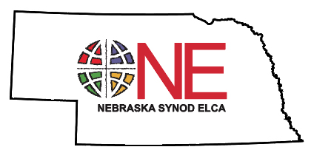
This resource has been created, compiled, and curated by Deacon Timothy Siburg for the congregations of the Nebraska Synod, ELCA for the 2023 (Year A-B) and 2024 (Year B) program ministry years. It may be used, shared, and adapted as useful for your congregations. If you have questions or creative ideas of ways to incorporate this in your ministry context, please contact Deacon Timothy at: timothy@nebraskasynod.org.

Charles R. Lane, Ask, Thank, Tell: Improving Stewardship Ministry in Your Congregation, (Minneapolis, MN: Augsburg Fortress, 2006), and can be ordered via Amazon here: For further help and resource, I also highly recommend: Reflections on Faith and Finances: A guide for individuals and groups based on Ask, Thank, Tell, (Charles R. Lane, 2019), and that can be ordered here: https://embracingstewardship.com/products/reflections-on-faith-finances.
Philippians 4:4, NRSV.

