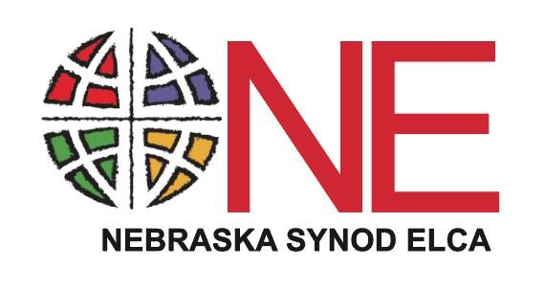
2023 Congregational Leader Directory

Please return to the Synod Office
Nebraska Synod ELCA
6757 Newport Ave. Suite 200, Omaha, NE 68152 office@nebraskasynod.org

PLEASE PRINT OR TYPE

Congregation ID/PIN: ☐ Changes check here

Cluster: Congregation:

Mailing Address: Meeting Address:

Church Phone: Area Code:
Preferred Email address: Church Web address:

 | Name | Mailing Address | Zip  Code | Email | Preferred  Phone | Phone Type  (home, cell, work)
Council President
Council Vice President
Council Treasurer
Council Secretary
Office Administrator

Additional Staff:

