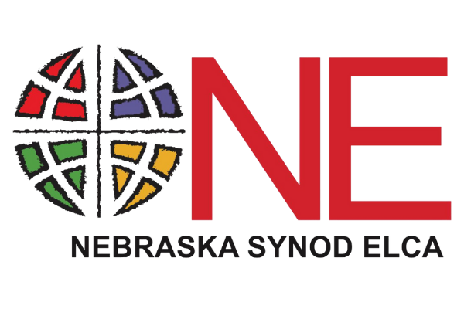
2022 Nebraska Synod ‘One Another’ Grant Application

Congregation or Synod Ministry:
Primary Contact (Name, Phone, Email):
Address:
Phone:
Email:

Please list all organizations (including community groups, ecumenical partners, and other congregations and synod ministries) involved in this project:
__________________________________________________________________________________________________________________________________________________________________________________________________________________

Please tell us about your food or hunger ministry (no more than 300 words).

___________________________________________________________________________________________________________________________________________________________________________________________________________________________________________________________________________________________________________________________

We anticipate grants to be $500. How do you anticipate using these funds in your community? (no more than 300 words)

___________________________________________________________________________________________________________________________________________________________________________________________________________________________________________________________________________________________________________________________

Have you ever applied for an ELCA World Hunger grant in the past?
[ ] Yes [ ]No

Have you ever applied for a One Another grant in the past?
[ ] Yes [ ]No

Please send all typed or handwritten requests by November 11, 2022 to:

Nebraska Synod, ELCA
ATTN: One Another Grant
6757 Newport Ave., #200
Omaha, NE 68152
office@nebraskasynod.org

If you have questions about One Another grants or wish to have someone come speak about ELCA World Hunger, please contact the Nebraska Synod office at (402)-896-5311 or by email at office@nebraskasynod.org. If you have questions regarding this application, please contact Jenny Sharrick at (402)984-9753 or by Jennifer.sharrick@gmail.com.

