Nebraska Synod, Evangelical Lutheran Church in America
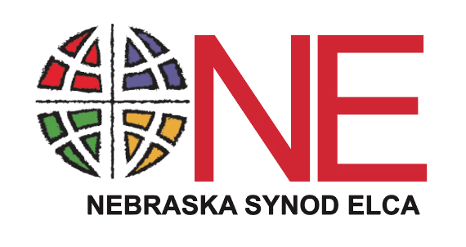

2022 Mission Share Commitment Sheet

Congregation:
City:

ELCA ID#:

Thank you for your partnership, as we are church together! Your mission share offerings support a variety of ministries here and around the globe, changing lives as together we do God’s Work with Our Hands!

YTD as of November 30, 2021:

Your Previous Mission Share:

2018:
2019:
2020:
As we celebrate God’s abundance, we would like to invite you to prayerfully consider growing in your financial partnership.

Thank you for your consideration, for your partnership, and for all of the ministry that you do and is made possible through you.

$

Your 2022 Mission Share Intent is:

What are other ways that your congregation and the Nebraska Synod
can walk together in the year ahead? (please check all that apply)

- Have your Assistant to the Bishop visit and preach
- Invite other synod staff to visit
- Invite a serving arm ministry to visit
- Consider the potential for Transformational Ministry
- Attend an upcoming Nebraska Synod Road Show
- Other (please explain on back)

Submitted by:

________________________________________________
Please complete this sheet and return it to the Synod Office by February 15, 2022.
Nebraska Synod, 6757 Newport Avenue, Suite 200, Omaha, NE 68152.
If you have any questions, please contact Deacon Timothy Siburg, Director for Stewardship at: timothy@nebraskasynod.org or (402) 896-5311

