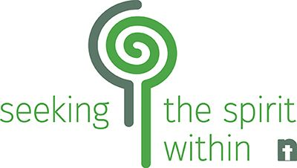
SIP FROM THE WELL
Select prayer practices offered as a ministry of Seeking the Spirit Within with the Nebraska Synod Institute for Spiritual Direction Formation.
November 2, 2021 Forgiveness, Pastor Brad Meyer
January 4, 2022 Zentangle, Diane Harpster
March 1, 2022 Bio-spiritual focusing, Patty Forsberg
May 3, 2022 Body prayers, Pastor Eric Spruth-Janssen
Facilitators: Patrick Gregory, Emily Wageman
Register for all sessions at a reduced rate of $160.00. They will be held via Zoom on the first Tuesdays of select months from 7:00 – 9:00 P.M. Small groups will meet with spiritual directors within the 2-hour timeframe to practice and to discuss what was discovered in their own practice. Register by October 26 at nebraskasynod.org/discernment-vocation/spirituality/drink-from-the-well/
May register for one class at a time for $45 each.
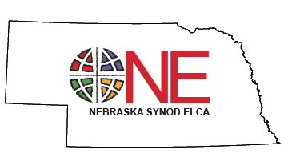
Register for single session with the same link above:
November session by October 26
January session by December 28
March session by February 22
May session by April 29
Questions may be directed to Pat or Emily at dftwnesynod@gmail.com

Sip from the Well will be held in 2021-22 to share a ‘sip’ of the full Drink From the Well ministry program that was not able to happen this year.

